**CNCITY Dataset - Exploratory Data Analysis  
(February + April)**

1. **Parsing and tabulating the data**
   1. Done through Cassandra_query and other Python packages

(20240603)

1. **Plotting each variable (stationarity, moving average, seasonality, etc)**
   1. Electricity_1: seems relatively stationary, does not display seasonality 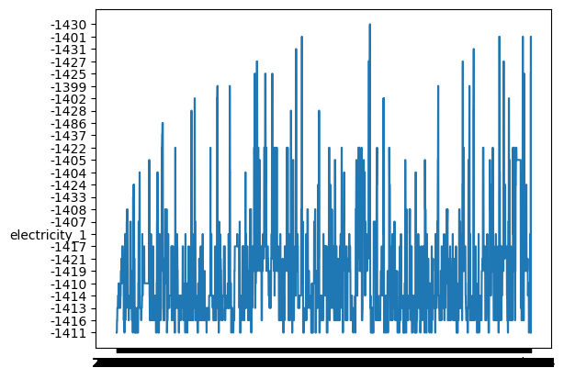
   2. Outside_temperature: ranges from 12 to 22 degrees Celsius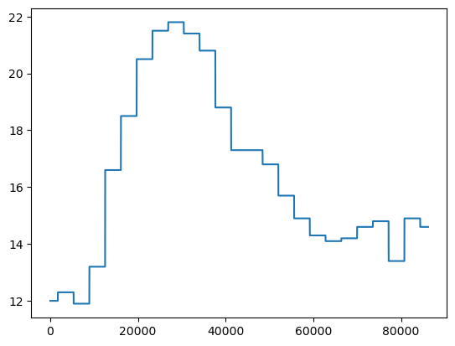
   3. Pressure_1: 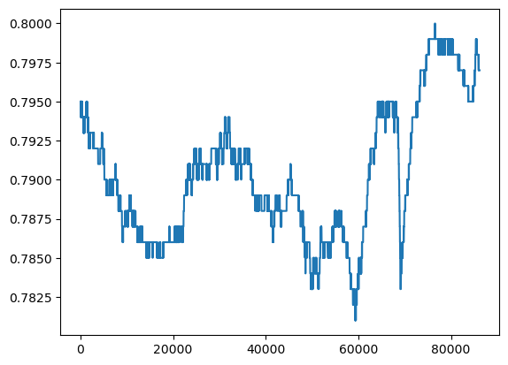
2. **Linear Regression**
   1. Outside_temperature and pressure_1
      1. Split the data frames into train and test sets
      2. Train the model using x_train and y_train, then run it on x_test to evaluate and further improve accuracy
      3. 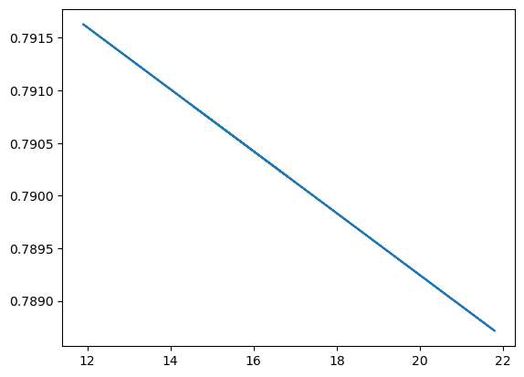
      4. Temperature and pressure are negatively correlated
      5. y = -0.0002944x + 0.795132
   2. Electricity_1 and pressure_2
      1. 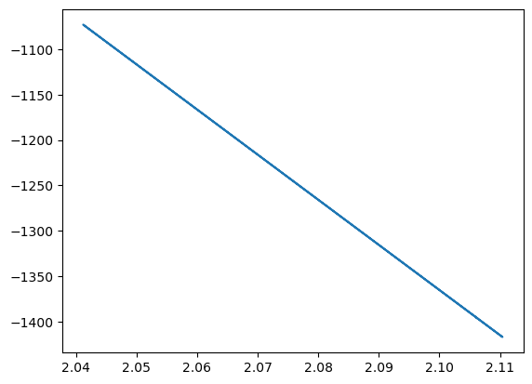
3. **Autocorrelation (Test for stationarity)**
   1. 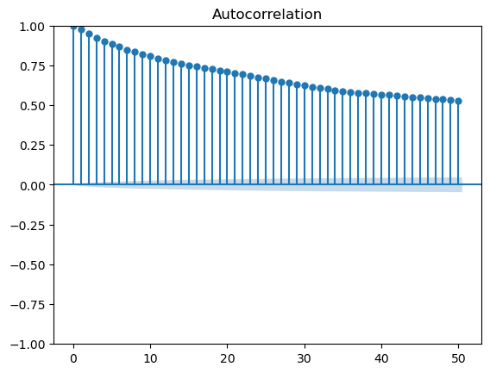
      1. Electricity_1 - non-stationary
      2. Blue-shaded region: confidence interval
      3. **Suggests that the dataset might be non-stationary** 
         1. Slow decay of autocorrelation

* The autocorrelation plot tends to drop quickly in a stationary time series  
  + - 1. Persistent correlations
* Our dataset displays higher autocorrelation values at longer lags
  + 1. Need to make the series stationary before analyzing it (moving average method, rolling average, etc)
  1. **Pressure_1 - non-stationary (log transformation did not work)**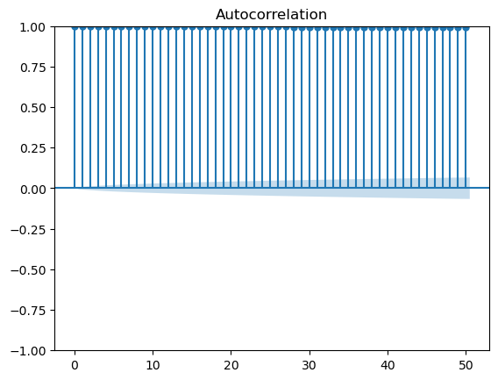

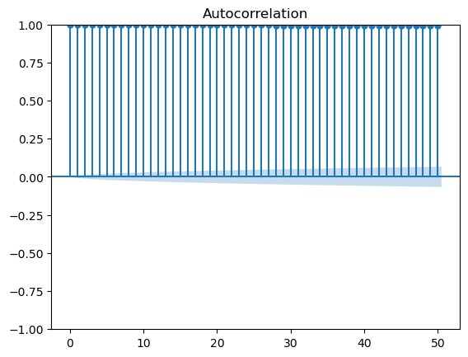 (after applying log transformation)

1. **Moving average (Rolling average)**
   1. Electricity_1 (window = 1,000)

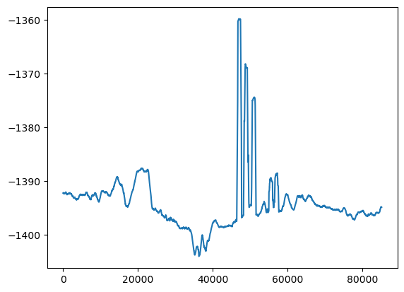

* 1. Window = 10,000  
     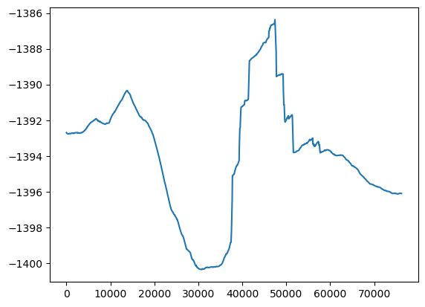
     1. The steep rise and fall between indices 30,000 and 50,000 indicate periods of higher volatility
  2. Pressure_1 (rolling average)
     1. Window = 1,000  
        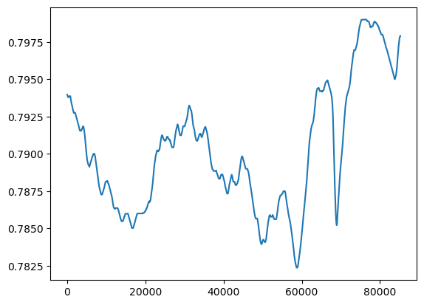
     2. Window = 10,000  
          
        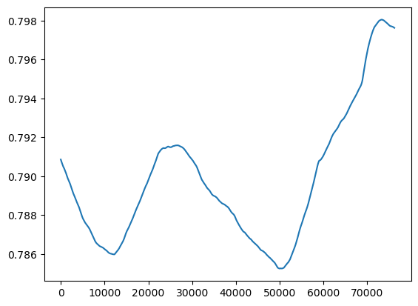

Plotted ‘is_maintenance’ versus Time

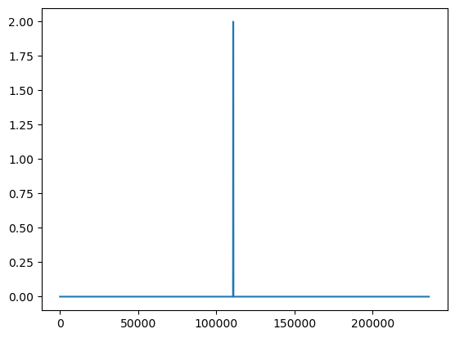

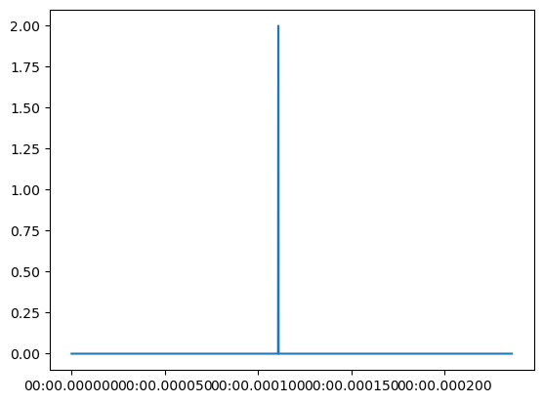

(maintenance_df → the indices are different)

Autocorrelation plot (is_maintenance)

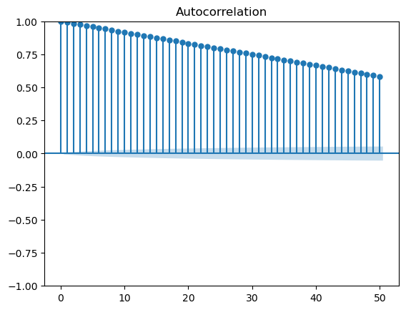

Pressure_2: (lag plot)

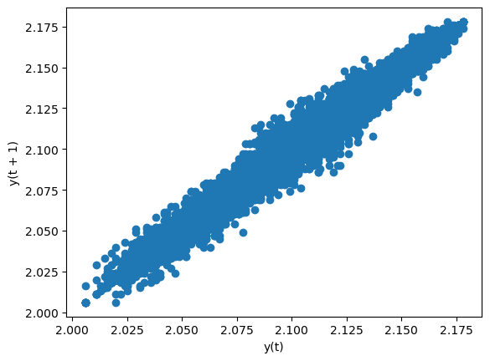

**6/13/2024:**

df['pressure_1'].corr(df['pressure_1'].shift(1000)): autoregression, lag = 1,000

Output: 0.9184823349674819

df['pressure_1'].corr(df['pressure_1'].shift(1000)): autoregression, lag = 1,000

Devised a different approach to preprocessing the data:

* Wrote a function called ‘**process_dataframe**’ that takes a dataframe and returns a new one.
* Our dataset has a column called ‘Time’ that starts at 0 and ends at 235959 (midnight)
* ‘Process_dataframe’ takes the dataset and groups the data by hour based on the ‘time’ column
* Then it computes the mean, median, mode, or max of the other columns for each hour group
* After that it creates a new dataframe with all these values

Result_df: our new dataset (consolidated), has a new column called ‘Hour’

**Visualization: (graphs)**

1. **Electricity_1**

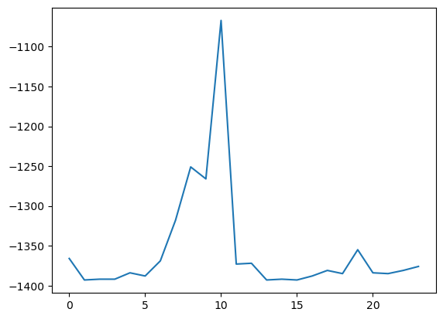

1. **Pressure_1**

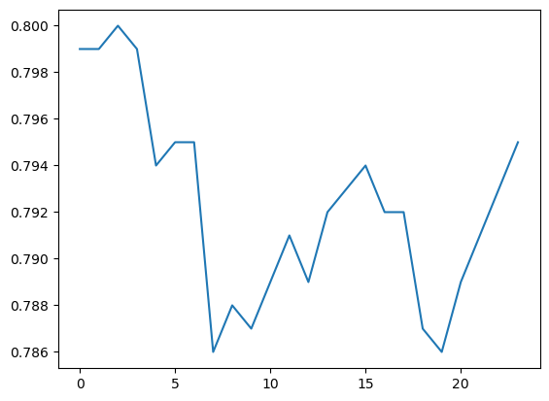

1. **Pressure_2**

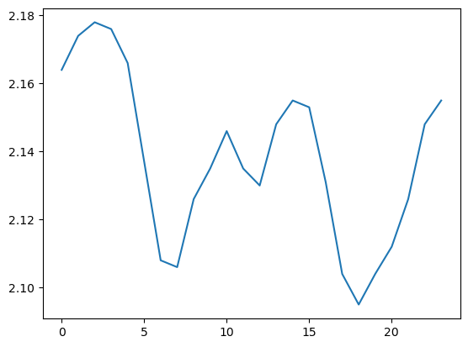

1. **Electricity_2**

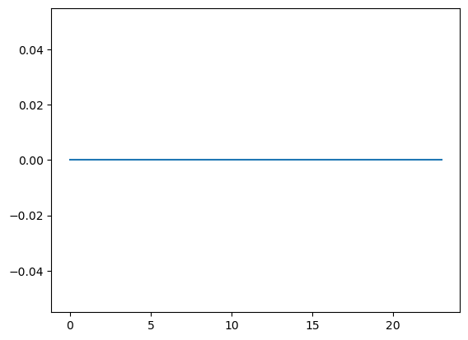

1. **Outside_temperature  
   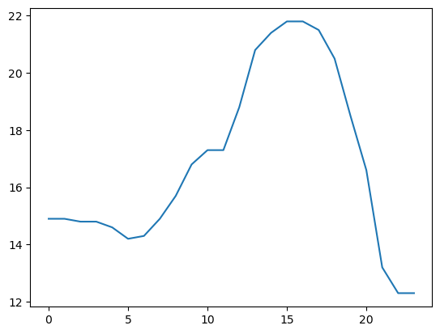**
2. **Is_maintenance  
   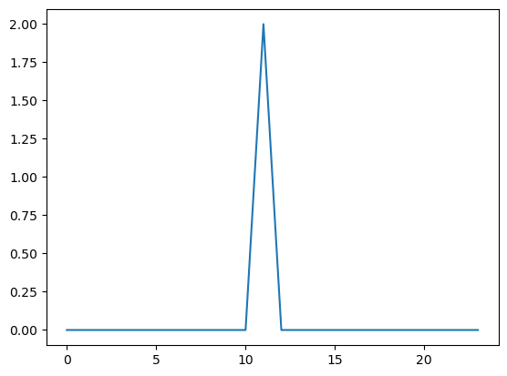**
3. **Door_open  
   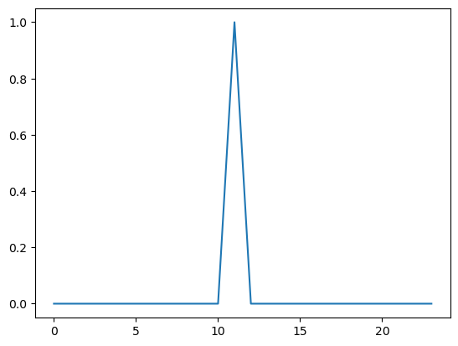**

**6/17/2024:**

**Pressure_2:**

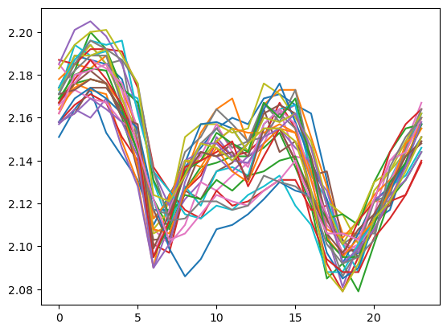

**Pressure_1:**

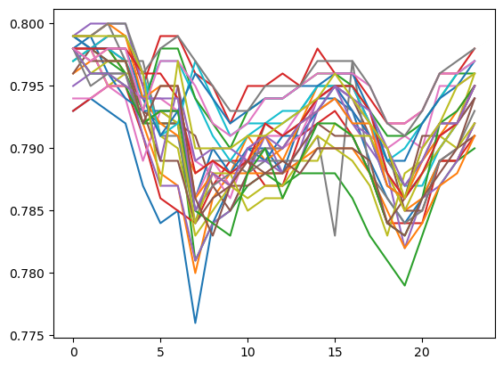

Pressure_1 (mean): April

* Queried/processed a month’s worth of data

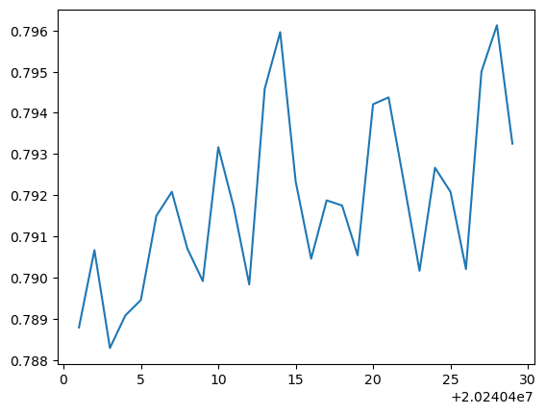

Pressure_1 (mean): February

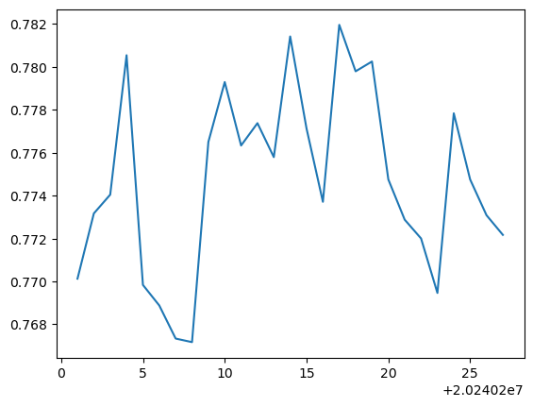

Did the same for ‘Pressure_2’

**April:**

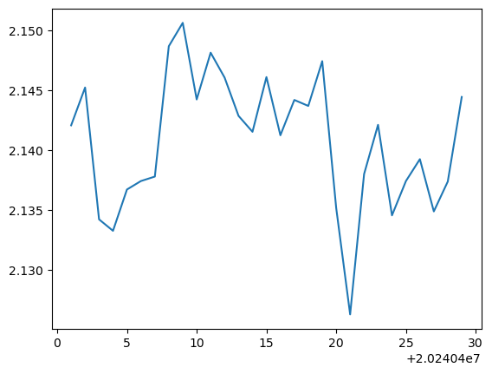

**February:** 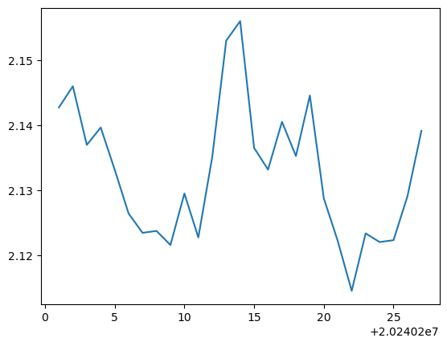

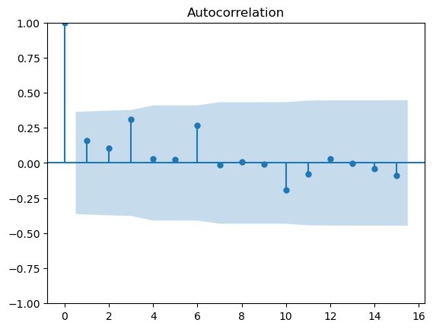

**Autocorrelation plot (variable = ‘pressure_1’, max, month = April)**

**Lag 1 to 15:**

Lag 1: displays a significant spike above the confidence interval, suggests a significant positive autocorrelation

Electricity_1 (April and February) 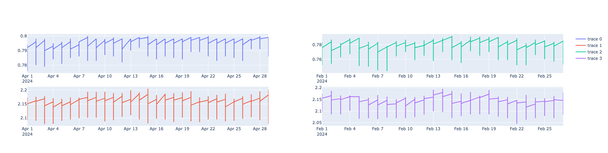



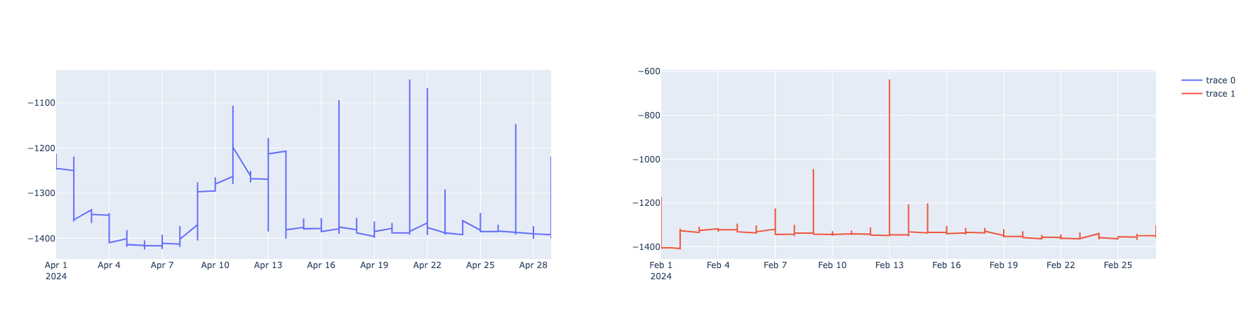

February + April

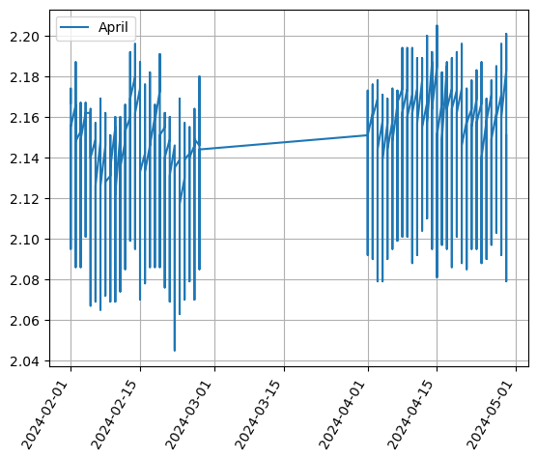

The data from March seems to be embedded with irregularities and exceptions:

processed_dataframe_list_4 = []

start_date = 20240301

while start_date < 20240330:

df_2 = query(start_date, 1)

new_df_2 = process_dataframe(df_2, 'max')

processed_dataframe_list_4.append(new_df_2)

start_date+=1

del df_2

del new_df_2

final_df_mar = pd.concat(processed_dataframe_list_4, axis =0)

final_df_mar.head()

~/anaconda3/lib/python3.11/site-packages/pandas/core/frame.py in ?(self, by, axis, ascending, inplace, kind, na_position, ignore_index, key)

**6754** elif len(by):

**6755** # len(by) == 1

...

**1779**

**1780** # Check for duplicates

**1781** if values.ndim > 1:

KeyError: 'time'

MongooseAI: (brevity is key) – for future interviews

Week 1,2: Titanic EDA (Kaggle): linear regression, logistic regression, decision trees, randomforestclassifier: used different classifiers to predict the surviving passengers

Week 3,4: CNCITY, Titanic

* CNCITY: (include a brief intro explaining the project, )
* Queried, processed (consolidated), and concatenated a month’s worth of data
* Measurement of misalignment, identifying outliers

Week 5: CNCITY

* Measurement of misalignment, ‘pressure_1’
* Subplots
* Identifying false alarms and missed detections using the event data (db_1 and IoT_1 have different # of columns and rows)